Problem Statement
To design and implement a Recurrent Neural Network (RNN) / Long Short-Term Memory (LSTM) model to analyze sequential data and perform prediction or classification tasks such as time series forecasting or sentiment analysis.

1. Dataset Source
- Airline Passengers Dataset
https://raw.githubusercontent.com/jbrownlee/Datasets/master/airline-passengers.csv

2. Dataset Description
- Monthly airline passengers data
- Features: Month, Passengers
- Target: Passenger count prediction
- Size: 144 records
- Type: Time series

3. Mathematical Formulation
- RNN:
- $h_{t}=tanh⁡(W_{h}h_{t-1}+W_{x}x_{t}+b)$
- LSTM uses gates (forget, input, output) to manage memory and improve learning.

4. Algorithm Limitations
- RNN struggles with long-term dependencies
- LSTM is computationally expensive
- Requires large datasets
5. Methodology / Workflow
Steps:
- Load dataset
- Normalize data
- Create sequences
- Train-test split
- Build LSTM model
- Train model
- Predict and evaluate

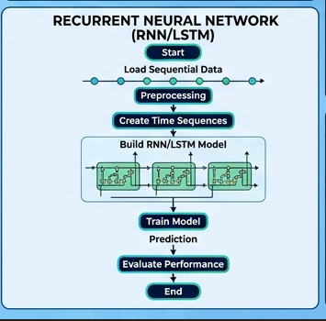

6. Performance Analysis
- Metrics: MSE, RMSE
- Observed accurate trend prediction
- LSTM performs better than RNN

7. Hyperparameter Tuning
- Units: 50
- Epochs: 20
- Batch size: 16
- Optimizer: Adam
→ Improved accuracy and reduced loss

